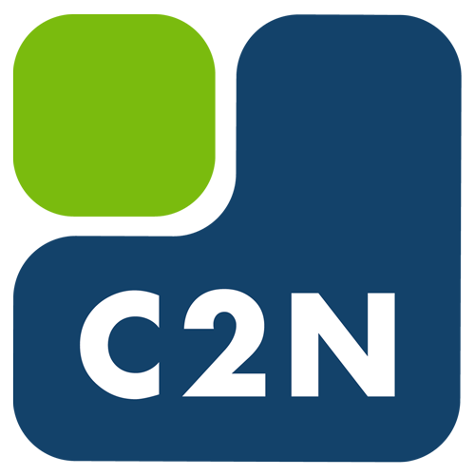
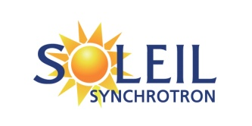
L'Orme des Merisiers, Saint-Aubin
BP 48 - 91192 Gif-sur-Yvette Cedex, FRANCE

Poste – Post-Doctorat | Mise à jour : 11/12/2020 | Référence : xxx | Division : EXP
Characterization by infrared spectroscopy of heterostructures in Germanium and Silicon nanowires.

SOLEIL is the French national synchrotron facility, located on the Plateau de Saclay near Paris https://www.synchrotron-soleil.fr/en . It is a unique tool for both academic research and industrial applications across a wide range of disciplines including physics, biology, chemistry etc... It is used annually by thousands researchers from France and abroad. SOLEIL is based on a synchrotron source that is state-of-the-art both in terms of brilliance and stability. This large scale facility, a partner of the Université Paris Saclay, is a “publically owned” private company, founded by the CNRS and the CEA.

This position is for working in the AILES beamline group, in the Experience division.
The AILES infrared beamline https://www.synchrotron-soleil.fr/en/beamlines/ailes was designed to exploit the spectral range extending from the infrared to the THz with source stability as high as possible. The scientific program is devoted to Optical and Spectroscopic studies and concerns a large scientific community. Since its opening in 2009 the studies exploiting the beamline have permitted the publication of about 300 articles and 8 theses. https://www.synchrotron-soleil.fr/en/publications?field_lignes_de_lumiere_tid=11
Among other characteristics, the high brightness and the great stability of synchrotron radiation coupled with various spectrometers operating under vacuum makes it possible to study samples having sub-micron sizes with excellent sensitivity. Specific set-ups allow to measure under well controlled pressure and temperature conditions [1].
The AILES team includes 4 researchers, 1 engineer, 1 technician and one thesis student.

Mission
At C2N, the team of L. Vincent has developed an original process for producing crystalline phase of Si and Ge nanowires, with transformations leading to the formation of hexagonal 2H domains along the 3C nanowires [2,3]. The hexagonal crystal polytype Ge-2H exhibits direct bandgap semiconductor in the mid infrared range [4]. Indeed, such heterostructured 3C/2H nanowires provide new prospect of additional opto-electronic functionalities of group-IV semiconductors (Ge and SiGe).
HEXSIGE project (https://anr.fr/Project-ANR-17-CE30-0014) is a fundamental scientific project funded by the French ANR (2017-2023) with a twofold objective:
(1) Investigating the size-related mechanical properties, identifying the driving force of the transformation and understanding the mechanisms of phase transformation in Si and Ge NWs. This study must enable the optimisation of the process for the synthesis of 3C/2H heterostructures.
(2) Providing an exhaustive knowledge of the basic physical properties of Ge-2H and Si-2H structures and on the resulting heterostructured 3C/2H NWs in order to identify their potential applications. All the aspects of electronic, optical and vibrational properties will be investigated by means of a thorough experimental approach associated to theoretical calculations. Among other parameters, particular attention will be paid to the determination of the band gap of the 2H phases still lacking in literature. For that concern, comparison of EELS measurements and infrared absorption are of particular interest.
Additionally, new routes are investigated for the synthesis of Ge-2H layers. This study benefits from a unique E-TEM with in-situ growth for real time observation. This unique tool on the “plateau de Saclay” enables to study the influence of growth processes, precursors, impurities, etc.

[1] : F. Capitani, et al., Nature Physics., 13 (2017) 859.
E. Falsetti, et al., Physical Review Letters., 121 (2018) 176803
[2] : L. Vincent, et al., Nanoletters 14 (2014) 4828
[3] : L.Vincent et al., Nanotechnology 29 n°12 (2018) 125601
[4] : T. Kaewmaraya, L. Vincent and M. Amato, The journal of physical chemistry C121 -10 (2017) 5820

Responsibilities and tasks

At the C2N, with L. Vincent, you will participate to the following tasks:
- Synthesis of polytypic Ge-2H and Si-2H phases by phase transformation in nanowires (clean room work at C2N) and development of novel growth methods.
- Electronic gap measurement of Ge and Si under pressure in the UV-Visible-NIR range.

At SOLEIL, within the AILES team, you will be involved in the following measurements and developments:
- Band gap and phonon measurements of Ge and Si in bulk under pressure and at controlled temperatures.
- Measurements of Phonons and band gap in Ge and Si heterostructured wires 2H/3C at controlled temperatures and pressure.
- Source adaptation and UV-Visible detector for high pressure measurement.
- Adaptation of a high temperature oven for the AILES high pressure cell.

Infrared absorption measurements under pressure and temperature

Complementary measurements
    - Additional measurements by Raman under pressure and by SNOM (near-field optical microscope scanning) of Ge and Si heterostructured wires 2H/3C.

Education and experience
This job is intended for a holder of a doctorate degree, specializing in solid state physics, with knowledge in optical spectroscopy if possible.

Basic knowledge and skills Indispensable  (basic knowledge and skills required for the position)  - Solid state physics  - Knowledge of experimental methods for determining the physical parameters of nanomaterials. | Additional knowledge and / or skills  (Knowledge or know-how not essential but which constitute assets)  - Infrared spectroscopy  - Competence in solid state physics under high pressure  - Experience in developing experimental set-up.
Required qualities  (Behavioral qualities required for the position)  - Autonomy and ability to define priorities.  - Ability to work in a group in a synchrotron facility. | Techniques / means used  (Specific work tools whose handling is desirable or even essential for the position)  - Fourrier transform infrared spectroscopy  - High pressure technique  - Vacuum and cryogenic technique  - Infrared spectrum analyses

General conditions of exercice
This offer corresponds to a fixed-term contract. The remuneration will be based on the SOLEIL salary scale, and will be determined according to the candidate’s qualifications and professional experience. The contract can start in January 2021. This job description is not exhaustive. It considers the main responsibilities and can evolve.

The application must be sent by email, it must contain a motivation letter and a curriculum vitae.
Contact :
Jean-Blaise Brubach (Soleil) : jean-blaise.brubach@synchrotron-soleil.fr
Pascale Roy (SOLEIL) : pascale.roy@synchrotron-soleil.fr,
Laetitia Vincent (C2N) : laetitia.vincent@c2n.upsaclay.fr.

